Save Elmwood Timeline

2012 Merger Proposal Document* - Barony College, Elmwood College, Oatridge College and the Scottish Agricultural College (SAC), “a fusion of what is best about the partner organisation”.
Cash at bank (due diligence 2011):
- Barony £60k
- Elmwood £3.6m (contracts for £836K for accommodation provision for students with profound/complex needs)
- Oatridge £2.2m (£8m backlog of maintenance/capital investment)
- SAC £1.3m (liabilities of £5.3m)
All EXCEPT Elmwood had borrowings - that may need repaid.

2015
- SRUC sells Auchincruive farmland and buildings.
- Rural Affairs Committee writes to SRUC Chair with concerns after a letter from a whistleblower.
- Scotland under its UK membership signs up to the UN Sustainable Development Goals (SDG).

2016
- Elmwood’s farmland and buildings are sold.
- Educational Institute for Scotland (EIS) writes to SRUC Board with concerns.
- Fife College vacated the shared Elmwood Campus, Parliament 30-03-17:
“decision to split Elmwood between Fife College and SRUC was inherently unstable. SRUC had well-publicised leadership issues and there were clear financial issues… “Fife College claiming that it was unsustainable for it as it had none of the assets but was expected to pay a share of the costs.”

2018 SRUC strategy announced – SRUC expects to make £100m in revenue by 2023.

2019
- SRUC sells Auchincruive campus
- SRUC invests £350K in Elmwood Animal Care Unit (ACU).

2020 SDG Network Scotland releases a report, no sign of further reports.

2021
- SRUC business plan for a new vet school, for 100% domicile students.
- The Ferret reports “College sell-off deprives West Scotland of Rural Education”.
- Scottish Farmer reports “New vet school will not solve recruitment issues”.

2022 SRUC Strategic aims and vision change, to be an Enterprise University with alignment to
UN Sustainability Development Goals (SRUC Report & Financial Statement).

2023
- SRUC strategy 2018–23 ends; Board focuses on a Financial Recovery Plan.
- First Minister’s Environment Council (co-chaired by Ian Boyd, see 2026 below) publishes “Scenarios for a resilient net zero and nature-positive Scotland in 2045”; quoting by 2027 “The Partnership sets up an Advisory Service to support farms to transition… Farmers – not an easy group to provide CPD for – were harder to reach and an early action by the Partnership was to set up and resource an Advisory Service which was, to all intents and purposes, a change agency.”
2024
- SAC Consulting, part of SRUC, secures a contract extension to continue delivering the Scottish Government’s Farm Advisory Service (FAS) to 2027.
- Elmwood ACU closure is discussed and consulted on, but courses run for another year.
- Elie & Earlsferry Community Council make a Participation Request, which ultimately fails when SRUC state they will make the decisions and the Outcome Improvement program (to improve student outcomes) is not progressed. The money from the sale of the farm at Elmwood, the sale of the Golf Course and the land on which the main buildings at Elmwood sit, to be used to get SRUC out of debt. Research showed the majority of the debt was incurred at the other SRUC sites.
- SRUC dissolves SAC Foundation, SAC Commercial Ltd becomes SRUC Innovation.
- SRUC deficit doubles over the year, financial year is extended to July leaving c.2 years from March 2024 until next published financial statement.
- Financial Recovery Plan Board formed but has no non-executive members.
- Scottish Funding Council question the Vet School and how to make it work in a deficit, when UOE and UoG struggle (March Board Minutes).
- SRUC’s CEO pauses capital spend until clarity on cash reserves (June Board Minutes).
- Auditors discuss a banking facility (September Board Minutes).
- SRUC’s Board looks for better internal controls and faster action on audit points;
Board agrees to close Elmwood ACU (December Board Minutes).
- Subsidiary SRUC Innovation Ltd reports net current liabilities £1.86m (£1.4m in 2023;
see 2025 below).
- SRUC reports – deficit £10.8m; loans £23m; cash & current assets inv. £14.6m (£24.1m: 2023).

2025
- Protests are held in Cupar in March about proposed closure of Elmwood ACU; proposals and attempts to find a solution with SRUC fail.
- Board asks CEO/Executive to ensure internal control systems are working effectively;
SRUC’s Board discuss a Bank facility (March Board Minutes).
- Elmwood ACU is closed in April.
- EIS staff 97% vote of no confidence in SRUC management in May and SRUCSA issue a statement supporting the vote.
- SRUC’s CEO tells Parliament’s Education Committee in June “We have not had our accounts fully audited, but we anticipate that the deficit has been reduced to £5million this year. Moving into this financial year, we anticipate that we will be close to breaking even and will, subsequently, move into surplus.”
- SRUC’s June Board Minutes:
- Bank facility approved in principle
- The goals of the CEO and Chair are difficult to reconcile – the Chair wants stability, the CEO wants change
- Cyber security is a critical issue
- The Board will not use domain emails, the Chair email will be monitored, FOI request confirms all contact is through executive office
- Accreditation of the Vet School is required by the Royal College of Veterinary Surgeons, the Board agree capital spend to build a Ruminant Handling Facility and a Small Animal Teaching Clinic.
- Chair steps down in July, after being re-elected unanimously in December 2024 from April 2025 for
3 years.
- CEO of Scottish Funding Council responds to Save Elmwood’s concerns:
“In relation to coherent provision, SRUC has advised us that while most students in Animal Care courses find employment, much of this is in lower-paid, part-time roles, and progression into professional posts, such as veterinary nursing, is low. These outcomes are part of the context SRUC considers when making decisions about curriculum and estates planning.”
- SRUC Innovation 2025 Report and FS, July 2025:
Elmwood Golf achieved an improved result, was stable and continued to support student learning while Vets commercial operations, Physical Services and Commercial Ventures had worsening results. Yet…
- SRUC’s September Board Minutes:
- “The [Elmwood] golf course was not required for any current golf course management courses and as such should the golf course be sold it would not negatively impact the teaching and learning experience”
- “The potential reputational impact of each of the options were discussed. It was noted it would be preferable if the golf course were to be sold as a going concern”
- Bank facility still in negotiation.
- MSP Willie Rennie attends a SRUC Board meeting in Sept, but this is not reported in the minutes or to Save Elmwood; he responds to requests for the Education Committee to hold an evidence session into SRUC that this is being considered and that details will be confirmed – none are received.
- 18-09-25 Meeting held at Elmwood House between Community Groups and SRUC, SRUC refers to excess space (including boarded up building) but cannot define what this is.
- 18-12-25 Meeting held at Elmwood House, SRUC still unable to define “dead” space:
- community asks for funds gained from sale of any land to be provided back to Cupar
- Strategy director who joined in March 2025 from Dundee University leaving April 26
- Richard Armitage (Head of School) confirms new Golf Management degree is online with no practical side.
- Courier article misrepresents Elmwood by using old pictures (pre-boarding up) and by quoting the CEO stating investment and presence at the campus through a new golf degree, omitting this is online and can effectively be run from anywhere.
- MSP Alex Rowley asked a question in parliament about Elmwood to FE/HE Minister Ben McPherson, who agrees to meet Save Elmwood.
- SRUC’s December Board Minutes:
  - new focus on “Transnational Education” to mitigate risks associated with international students
  - partnerships in China
  - Board remit to include charity and trustee elements of Board’s duties
  - RAVIC needs new 5 year strategy and business plan as priority, Dairy Nexus review next year.
- Subsidiary SRUC Innovation Ltd reports – net current liabilities £1.94m
- Directors statement on going concern: “the company continues to have the support of its parent, SRUC [a charity], to underpin the going concern assumption”;
- Accounting policies: [directors] “have a reasonable expectation that the Company will be able to access the support of SRUC for the foreseeable future and thus be able to continue in operational existence.
- OSCR states “Charity trustees must be clear that if they use the charity’s assets to support a failing trading subsidiary then they are putting those assets at risk and failing in their duties.”
- SRUC reports – deficit £6.7m; loans £23m; cash & cash equivalents £10.6m; net current assets £427k (£10m: 2024; £23m: 2023).

2026
- MSP Murdo Fraser alerts that the Education Committee is holding an inquiry into SRUC; Save Elmwood’s submission to parliament for the meeting is accepted and published.
- 14-01-26 Parliament Education Committee Meeting with SRUC CEO/Principal Wayne Powell;
Gary Ross, National Officer for HE at EIS:
“Our members are distraught about the fact that Elmwood seems to be bearing the brunt of all of this. There is a distinct feeling that something similar could happen to the Oatridge and Barony campuses as well, and that there is a key focus on investment in Aberdeen, Edinburgh and, potentially, Inverness, with the rural and veterinary innovation centre. That would be catastrophic.”
- SRUC provide a plan identifying Elmwood’s minimum operational footprint and areas considered surplus to group who met in September and December 2025.
- SRUC announces Ian Boyd, a biology professor from St Andrews University (see 2023 above), will write an independent economic study of Elmwood and NE Fife; FOI confirms no remuneration but that his admin will be supported by SRUC.
- SRUC publishes new strategy:
- 1st version amends quoted Chair to Interim Chair (recruitment still to happen)
- strategic direction appears increasingly weighted towards international partnerships and commercial positioning, including activity in Asia, Africa and South America.
- Save Elmwood holds 100+ public meeting 26-02-26, SRUC does not attend; unanimous anger at what has happened and no confidence in SRUC. MSP Willie Rennie represents SRUC.
- FOI request responses from SRUC and Fife Council show a lack of note/minute taking of meetings.
- FOI shows Fife Council and SRUC communication, but confirms FC does not record meetings.
- FOI review request indicates representatives acting for SRUC, including Savills, were involved in discussions with Fife Council and external architects regarding potential future planning and development options for the wider Elmwood site, including pausing Tree Protection Orders and the site being made brownfield to circumvent Local Development Plan rules in order to allow a development submission.
- 23-03-26 Save Elmwood meet FE/HE Minister Ben McPherson – we ask him to save FE and skills training; protect Elmwood and NE Fife; hold SRUC accountable for its decisions and financial position. He is not able to intervene (ONS rules), but the meeting notes will go to the next government.
- 02-04-26
- Scottish Funding Council CEO responds to request for meeting – it is not appropriate to engage with third parties on matters relating to institutional performance, governance or other potentially confidential issues.
Save Elmwood responds with concerns relating to whether SRUC continues to fulfil the public purpose, strategic mission and charitable objectives for which it was created, publicly funded and granted charitable status.
- FOI request made regards asbestos management plan at Elmwood Campus.
- 13-04-26 News of a planned auction to sell off Elmwood assets, including listed items, causes local upset and concern about safety, in particular asbestos management.
- 14-04-26 Save Elmwood meet Fife Council regards the FOI findings and the Elmwood auction; a long follow-up list results. Concern follow-up regards asbestos management.
- Save Elmwood sends Scottish election candidates a pro-college manifesto and asks them to support the campaign; during 2 local hustings the Green Party and Conservatives commit to helping the Save Elmwood campaign.
- SRUC CEO responds to request about further community engagement (last in Dec 2025) that the new strategy director (taking up the role from the Scottish Funding Council) will consider what is appropriate and the new Chair (past president of the Royal College of Veterinary Surgeons) and the board will decide priorities and relevance.
- 30-04-26
- Save Elmwood informed at 4.45pm about SRUC meeting with NE Fife Area Committee (NEFAC) the next day; Save Elmwood had asked to be included in any meeting months before.
- 30/04/26 FOI response (re December 2025 Board minutes, response received 01/06/26 declined to supply draft minutes (NB Board met in March 2026):
“SRUC also notes that the final, approved minutes are regularly created, meaning transparency can be achieved without the corresponding risk of misleading that comes with releasing draft minutes. SRUC, therefore, considers that the public interest in applying the exemption outweighs the public interest in being provided draft minutes.”
- 07/05/26 FOI Response (re Fife Growth Study; a local contributor to the study report requested to see draft minutes): “SRUC, therefore, considers that the public interest in applying the exemption outweighs the public interest in being provided draft minutes.”
- 20/05/26 to 17/06/26 Save Elmwood writes to SRUC Board regarding concerns, correspondence has to go through the executive office, attempts to confirm this fail and remain unanswered.
- 02-06-2026 Scottish Information Commissioner decision:
“The Commissioner would still take the opportunity to note how the Authority appears to have been obstructive rather than helpful throughout and the contradictory nature of the extensive submissions provided.
“The Commissioner finds this case frustrating. The Authority submitted lack of resources and time as an explanation but also submitted thirty-six pages to defend its position. There is something contradictory in this approach, which is a repetitive theme in this case.
“He finds the Authority did not comply with its duty to provide advice and assistance in responding to the request.”
  - 12-06-26 SFC responds again regards SRUC’s autonomy, and:
“In respect of Elmwood, SRUC has advised SFC that it remains supportive of a transfer of surplus parts of the site for public use, where a suitable body is willing and able to take on the associated ownership and responsibility. To date, SRUC has been unable to identify a body or institution willing to take on the excess site at Elmwood. SRUC has advised that it continues to explore other viable uses for that excess site and would welcome feasible expressions of interest for community use. In the meantime, SRUC continues to bear the ongoing and significant burden of maintaining the excess land and buildings at Elmwood. SRUC has also advised that the condition of the main Elmwood building is a long standing issue and that remaining delivery has been relocated on site to Elmwood House and the horticultural facilities.”
  - FOI response about asbestos management shows vacant buildings last surveyed in February 2018; operational buildings only surveyed in April 2026.
  - June 2026 A property within Elmwood deeds and the stated “minimum operational footprint” is under offer with Galbraith.
  - 23/06/26 Save Elmwood writes to SRUC CEO about property sale and Board concerns. No reply.
  - 03/07/26 NEFAC responds to request for records of May and June meetings with SRUC – the former is quoted as a deputation, the latter was a site visit therefore records were not possible. Save Elmwood had repeatedly asked to take part in a deputation.
  - 06-07-26 Save Elmwood meets Fife Council Leader David Ross and Education Manager Karen Lees. Constructive action points agreed include:
- Protecting the Elmwood site so that its value stays within Fife.
- Fife Council will review Fife's FE provision alongside local employer requirements, with emphasis on land-based skills and a focus on NE Fife and Elmwood.
- Fife Council will review provision for post-school education opportunities for all students with additional needs, alongside Kilmaron School in Cupar, recognising the past support provided by Elmwood (and Fife Council funding) prior to the merger in 2012.
- Fife Council will engage proactively with SRUC about the anticipated Fife Growth Study and future plans for Elmwood.
- 14-07-26 Save Elmwood, Sustainable Cupar and Cupar Development Trust hold meeting to form a Working Group to explore options for Elmwood with a community benefit principle. Fife Herald: ‘Save Elmwood said: “We held a public meeting in Cupar in February which over 100 people attended. The overwhelming consensus was that the further education provision which SRUC has substantially reduced at Elmwood is still badly needed in north-east Fife, and that what SRUC’s offering falls well short of meeting the needs of local learners and employers.
“Many imaginative and creative ideas were put forward for the site, and everyone present wanted to see Elmwood retained for the benefit of the community. This working group has grown directly out of the ideas and energy expressed at that meeting.”’
  - 15-07-26 Meeting with Shadow Education MSP David Kirkwood in Holyrood, constructive action point to explore options for cross-party debate on SRUC and Elmwood.
  - 20-07-26 Meeting with Shadow Education MSP Jenny Young, constructive action point to raise governance, transparency and oversight issues.
  - FOI response from Scottish Government regards decision to close Elmwood’s main building and Animal Care Unit in April 2025 reveal references to factual inaccuracy in the consultation paper to staff/students, to SRUC’s continued engagement with community in March 2026 when there has been no engagement since Dec 25 and attempts by community have been ignored, a letter from the SRUC CEO to the Education Minister demonstrates a dismissive attitude towards college identity .
  - Letters sent to:
- Tertiary Education Secretary re request for meeting, IB Report response and links to J Withers.
- Scottish Funding Council - i) misleading FOI comment on community engagement, ii) misleading Board Minutes on development of Elmwood, iii) IB Report response and Working Group plans
- SRUC CEO, Wayne Powell, formal request to present evidence and amend approved Board Minutes (Item 26.14 - March 2026)
- Fife Council Leader re growing concerns on the pre-application discussions for residential development at the Elmwood site.

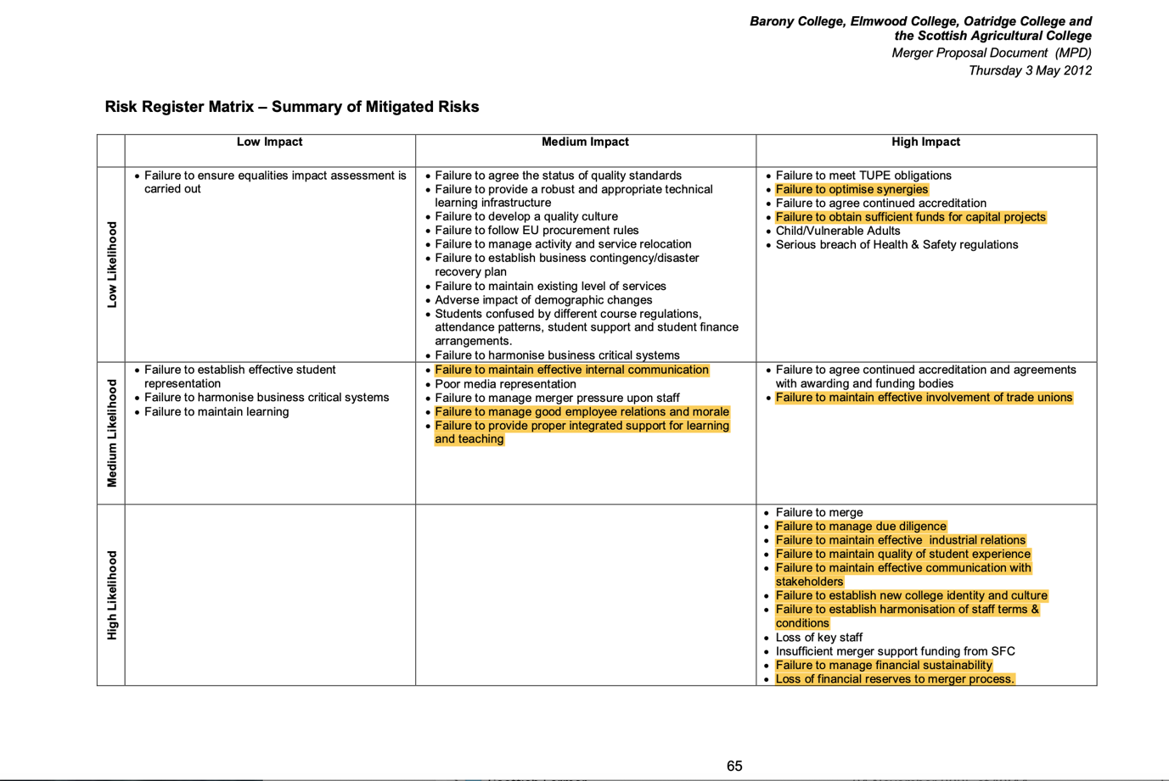
Appendix - SRUC Merger 2011 Proposal Document – Risk Matrix

